**THEME:**

***TOPIC:* WHOLE NUMBERS**

**SUBTOPIC: Counting numbers 1-100 orally both forward and backward**

**LESSON: 1**

|  |  |  |  |  |  |  |  |  |  |
| --- | --- | --- | --- | --- | --- | --- | --- | --- | --- |
| **1** | **2** | **3** | **4** | **5** | **6** | **7** | **8** | **9** | **10** |
| **11** | **12** | **13** | **14** | **15** | **16** | **17** | **18** | **19** | **20** |
| **21** | **22** | **23** | **24** | **25** | **26** | **27** | **28** | **29** | **30** |
| **31** | **32** | **33** | **34** | **35** | **36** | **37** | **38** | **39** | **40** |
| **41** | **42** | **43** | **44** | **45** | **46** | **47** | **48** | **49** | **50** |
| **51** | **52** | **53** | **54** | **55** | **56** | **57** | **58** | **59** | **60** |
| **61** | **62** | **63** | **64** | **65** | **66** | **67** | **68** | **69** | **70** |
| **71** | **72** | **73** | **74** | **75** | **76** | **77** | **78** | **79** | **80** |
| **81** | **82** | **83** | **84** | **85** | **86** | **87** | **88** | **89** | **90** |
| **91** | **92** | **93** | **94** | **95** | **96** | **97** | **98** | **99** | **100** |

***Teaching activity***

***Rote counting numbers forward and backward from 1-100.***

***Teaching Aids: Number chart 1 – 100 and counters.***

***REF: A New MK Primary Mathematics 2000 bk 1 page 49.***

**MK Old Edition Bk 1 page 40.**

**The National Primary school Curriculum for Uganda bk 1 pg 14.**

**Lesson: 2**

**Filling in missing numbers 1-50.**

|  |  |  |  |  |  |  |  |  |  |
| --- | --- | --- | --- | --- | --- | --- | --- | --- | --- |
| **1** |  | **3** | **4** |  | **6** |  | **8** |  | **10** |
| **11** | **12** |  |  | **15** |  | **17** |  | **19** | **20** |
|  | **22** |  | **24** |  | **26** |  | **28** |  |  |
| **31** |  | **33** |  |  | **36** |  |  | **39** | **40** |
| **41** |  |  | **44** | **45** |  | **47** |  | **49** |  |

***Teaching activity***

* *Counting*
* *Filling in missing numbers 1-50*

***T/A: counters, pencils and number chart.***

***Prepared work on sheet of paper.***

***REF: A New MK Bk 1 Primary Maths 2000 page 79.***

**Understanding Maths bk 2 page 12.**

**Lesson: 3**

**Filling in missing numbers 51 - 100**

|  |  |  |  |  |  |  |  |  |  |
| --- | --- | --- | --- | --- | --- | --- | --- | --- | --- |
| **51** | **52** |  | **54** |  |  | **57** |  | **59** |  |
|  |  | **63** |  | **65** |  |  | **68** |  | **70** |
| **71** | **72** |  | **74** |  | **76** |  |  | **79** |  |
| **81** |  | **83** |  | **85** |  |  | **88** |  | **90** |
|  | **92** |  | **94** |  | **96** |  |  | **99** |  |

**Teaching Activity**

Counting, filling in missing numbers 51-100.

Teaching Aid: Counters, number chart and prepared work on sheets of paper.

***REF: A New MK Bk 1 Primary Maths page 79.***

**Lesson 4**

**Numbers which come just before**

**Numbers from 1 -50.**

**Examples**

Which number comes just before……………?

_____, **6, ______ , 9 _________, 14, ___________,49.**

5 comes just before 6.

9 comes just before 10.

13 comes just before 14

48 comes just before 49.

**Exercise**

**Write the number that comes before**

**___,** 5 **___,** 20 **_____,** 18

, 9 ____, 47 _____ , 23

____, 30 ____, 12 _____, 48

**Teaching Activity**

Counting and writing

**REF: Understanding Maths bk 2 pg 12.**

**Primary Maths for Uganda bk 2 pg 4.**

**Teaching Aids: Number chars and counters**

**Lesson 5**

**Numbers which come just before**

**Numbers from 51 -100.**

**Examples**

_____ , 52 52 comes just before 53.

_____ ,65 64 comes just before 65.

_____, 76 75 comes just before 76.

**Exercise**

**Write the number that comes before**

**___,** 86 **___,** 60 **_____,** 78 **_____,** 97

____, 81 ____, 50 _____, 73 **_____,** 95

____, 62 ____, 55 _____, 78 **_____,** 91

**Teaching Activities: counting**

**Learning Aids:** chart and counters.

**REF: Understanding Maths bk 2 pg 4.**

**Primary Maths for Uganda bk 2 pg 4.**

**Lesson 6**

**Numbers which come just after…….. (1-50)**

**Examples**

4, **5. 5** comes just after **4.**

7, **8**. **8** comes just after **7.**

24,**25. 25** comes just after **24.**

49, **50**. **50** comes just after **49.**

**Exercise**

**Which number comes just after?**

**46, ________ 13, _______ 11, ______**

**22, ________ 33, _______ 20, ______**

**45, ________ 49, _______ 14, ______**

**Teaching Activity**

Counting

**L/aids: Counters and number chart**

**REF: Understanding Maths bk 2 pg 12.**

**Primary Maths 2000 bk 1 pg 76.**

**Week 3**

**Lesson 1**

**Numbers which come just after…….. (51-100)**

**Examples**

54, **55 55** comes just after **54**

64, **65** **65** comes just after **64.**

92, **93 93** comes just after **92.**

**Exercise**

**Write the number that comes just after.**

**56, ________ 42, _______ 80, ______ 92, ______**

**60, ________ 46, _______ 83, ______ 94, ______**

**58, ________ 44, _______ 84, ______ 91, ______**

**Teaching Activity**

Counting

**L/aids: Counters, a chart**

**REF: Understanding Maths bk 2 pg 12.**

**Primary Maths 2000 bk 1 pg 76.**

**Lesson 2**

**Numbers that come just between …….. (1-50)**

**Examples**

8, **9,** 10**. 9** comes between 8 and 10**.**

13, **14**, 15. **14** comes between 13 and 15**.**

26, **27**, 28**. 27** comes between 26 and 28**.**

35, **36**, 37**. 36** comes between 35 and 37.

**Exercise**

**Which number comes between……?**

**21, ____, 23 31, ____, 33 19, ____, 21**

**25, ____, 27 42, ____, 44 40, ____, 42**

**14, ____, 16 25, ____, 27 36, ____, 38**

**Teaching Activity**

Counting

**L/aids: Counters and a number chart.**

**REF: Understanding Maths bk 2 pg 12.**

**Primary Maths 2000 bk 1 pg 52.**

**Lesson 3**

**Numbers which come between 51 -100**

**Example**

54, **55,** 56 **55** comes between54and56**.**

65, **66,** 67 **66** comes between65and67**.**

89, **90,** 91 **90** comes between89and91**.**

**Exercise**

**Write the number that comes between;**

74, ___76 80, ___, 82 65, ___, 67

92, ___94 58, ___, 60 87, ___, 89

95, ___97 62, ___, 63 98, ___, 100

**Teaching activity: counting**

**Teaching Aids: counters, number chart**

**REF: Understanding Maths bk 2 pg 12.**

**Primary Maths bk 1 pg 52.**

**Lesson 4 & 5**

**Counting objects 1 -20 and matching**

**Examples**

**=**

**=**

**=**

Image result for treeImage result for treeImage result for treeImage result for treeImage result for treeImage result for treeImage result for treeImage result for treeImage result for treeImage result for treeImage result for treeImage result for tree

**=**

Image result for potsImage result for potsImage result for potsImage result for potsImage result for potsImage result for potsImage result for potsImage result for potsImage result for potsImage result for potsImage result for potsImage result for potsImage result for potsImage result for potsImage result for potsImage result for potsImage result for potsImage result for potsImage result for pots

=

**Matching numbers to pictures**

**10**

Image result for ballImage result for ballImage result for ballImage result for ballImage result for ballImage result for ballImage result for ballImage result for ballImage result for ballImage result for ball

**14**

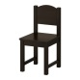

**12**

**Exercise**

**A. Count and write the number symbol**



=



**=**

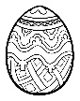

=



**=**

**B. Count and match**

= **15**

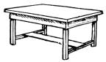 = **9**



= **5**

Image result for treeImage result for treeImage result for treeImage result for treeImage result for treeImage result for treeImage result for treeImage result for treeImage result for treeImage result for treeImage result for treeImage result for treeImage result for treeImage result for treeImage result for tree = **18**

**Teaching activity**

**Counting, matching**

**L/aids: Counters**

**Ref: Primary Maths 2000 bk 1 page 14-18**

**MK book 1 pg 49**

**Understanding Maths book 1 page25 second edition**

**MK Thematic book1 page 12**

**Lesson 6**

**Add 1 more and write the answer**

**Image result for ballImage result for ball**Image result for ball**Image result for ballImage result for ball**

**-- _______=**



**________=**



**_________=**

**Lesson 1and 2**

**Comparing two numbers up to 100 using is greater than and is less than (is smaller than)**

Example:

8 and 6 which is greater?

8 is greater than 6.

**Which is less?**

6 is less than 8.

85 and 98 **Which is greater?**

98 is greater than 85.

**Which is less?**

85 is less than 98.

**Exercise**

a) Circle the greater number.

11, 18 27, 17 98, 96

25, 38 44, 48 32, 45

76, 65 32, 39 13, 14

b) Circle the smaller number.

8, 10 31, 13 12, 21

16, 9 18, 16 44, 54

17, 20 23, 25 81, 91

**Teaching activity**

Counting numbers from 1-100

**L/A: Counters and number chart**

**Ref:  *MK Bk 1 page 13***

***Pri. Sch. Mtc. Bk 1 pg 52***

**Week 4**

**Lesson 1 and 2**

**Comparing numbers using least/ smallest (1-100) and greatest /biggest**

**Example:**

Which is the least number?

**E.g. 4 9 5 4 is the least number.**

Which is the largest / biggest number? **9 is the greatest / largest number.**

93, 98, 99Which is the least number?

**93** is the least / smallest number.

Which is the biggest / greatest number?

**99** is the largest / biggest number.

**Exercise**

a) **Underline the greatest number.**

28, 20, 23 22, 88, 41

35, 12, 40 76, 48, 43

14, 18, 12 82, 63, 85

b) **Identify the smallest / least number**

13, 11, 14 30, 36, 31 96, 81, 95

20, 24, 27 42, 40, 44 82, 78, 99

**Teaching activity**

Counting

**L/aids: Counters and number chart**

**REF: MK book 1 Maths page 13.**

**Lesson 3**

Arranging numbers beginning with the smallest (ascending order)

**Example:**

**8 5 7 = 5, 7, 8**

The number with the least objects is the smallest as shown.

33, 13, 31 - 13, 31, 33

88, 84, 86 - 84, 86, 88

**Exercise**

Arrange these numbers starting with the smallest (ascending order)

**a) 4, 3, 0 b) 32, 30, 31**

**b) 10, 12, 8 f) 82, 85, 81**

**c) 20, 12, 21 i) 91, 19, 94**

**Teaching Activity**

Arranging numbers

**Learning Aids: counters and number chart.**

**Ref: MK Primary Maths bk 1 page 13.**

**Lesson: 4**

Arranging numbers starting with the biggest (descending order)

**Examples**

**8 10 7 = 10, 8, 7**

**The number with more objects is the biggest.**

38, 34, 39 39, 36, 34

84, 55, 47 84, 55, 44

**Exercise**

Arrange these numbers starting with the biggest (descending order).

**a) 16, 52, 56 b) 47, 41, 48 g) 18, 80, 56**

**c) 11, 15, 19 d) 24, 21, 25 h) 20, 40, 70**

**e) 31, 34, 38 f) 11, 32, 40 i) 95, 93, 99**

**Teaching Activity**

Arranging numbers

**Learning Aids: counters and number chart.**

***Ref:***

**Lesson: 5**

**Comparing objects using non standard units.**

**New words: longer, shorter, bigger, smaller, taller**

**Example:**

 a) Which pencil is shorter?



b) Which pencil is longer?

**A B**

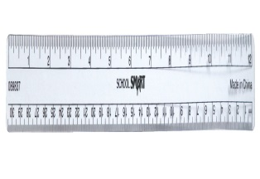a) Which ruler is longer?

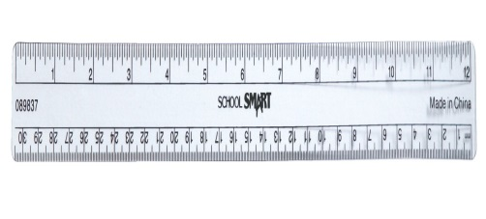 b) Which ruler is shorter?

**K R**

**Exercise**

1.Which tree is shorter? 2. Which tree is taller?

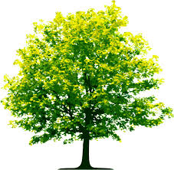



**S T**

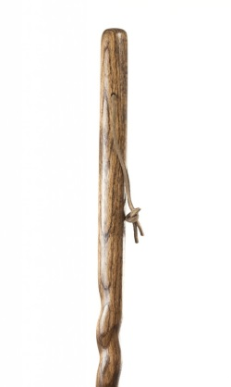2. Which stick is shorter?

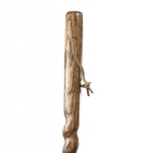

**N M**

**Please add more numbers**

**Teaching activities**

**Comparing objects**

**Teaching Aids: rulers, pencils, books, sticks and different containers.**

**Ref: National Primary School Curriculum for Uganda – Primary One**

**Lesson 6**

**Comparing capacity using different containers.**

**Example**

1.Which pot holds more liquid? 2. Which pot holds less liquid?

Pot R holds more liquid. Pot S holds less liquid.

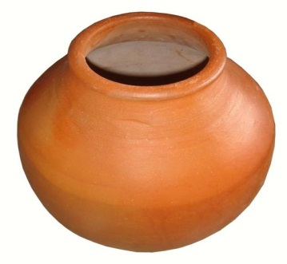

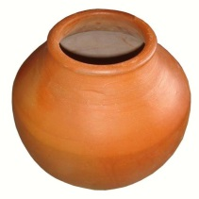

R S

**Exercise:**

1.Which bucket holds less liquid?

2.Which bucket holds more liquid?

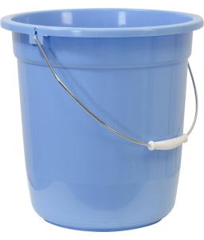

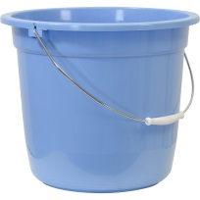

F Y



 1.Which cup holds more water?

2.Which cup holds less water?

E  **D**

**Note: Please add more numbers for practice.**

**Teaching activities:** Comparing and identifying

**Teaching Aids:** cups, buckets, basins, bottles, tins

**Ref: National Primary School Curriculum for Uganda – Primary One**

**Note: Review shapes (circle, rectangle, oval, triangle, kite and square)**

**Lesson 5 & 6**

**Place Values**

**Tens and Ones**

**Ones – The ones start from 0 to 9**

**e.g = 1 one = 2 ones** = **3 ones** = **4 ones**

**= 7 ones** = **5 ones**

- The ones have only one figure or digit. e.g. **1, 2, 3, 5, 6, 7, 8, 9.**

- We do not tie a bundle when the sticks are less than 10.

**Exercise:**

Draw and count the ones

1. 5 ones = ______________ e. 1 one = ___________
2. 7 ones = ______________ f. 6 ones = ___________
3. 4ones = ______________ g. 9 ones = ___________
4. 8 ones = ______________ h. 2 ones = ___________

**Teaching activities**

Counting the ones

**Learning Aids: counters.**

***Ref: A New MK Primary Maths Bk 1 pg 53 Understanding Maths book 1 pg 73-74***

**Practical lesson**

**Lesson: 3**

**The tens**

The tens have 2 digits e.g 10, 30, 20, etc

**1 ten = 10 sticks**

**Example**



**= 10 = 20 = 30**

**1 ten 2 tens 3 tens**

We tie a bundle when the sticks are 10 (ten)

**Teaching activity**

Counting and tying bundles of tens **(practical lesson)**

**Learning aids:**

Counters rubber bands and textbooks

**Ref: Understanding Maths Standard 1 second edition page 69-70.**

**National Primary school curriculum for Uganda pg 29**

**MK A new edition primary Maths book 1 page 44-45**

**Week 5 MIDTERM EXAMINATIONS**

**WEEK 6**

**Lesson 4**

**Tens and Ones**

Counting tens and ones (practically)

**Example:**



12 =

**1 ten 2 ones**



25 =

**2 tens 5 ones**

30 =

**3 tens 0 ones**

**Exercise**

Drawing and counting tens and ones

1. **13 =_______________ f. 21 =______________**
2. **22 =_______________ g. 43 = _____________**
3. **34 =_______________ h. 90=______________**
4. **15 = _______________ i. 66= _____________**
5. **50 = _______________**

**Teaching Activity**

Counting, drawing tens and ones

**L/aids:** Counters, rubber bands and text books

**Ref:**  Understanding Maths bk 1 second edition page 73.

**Example**

52 = **5** tens **2** ones

30 = tens

17 = **1** ten **7** ones

­­____ = 8 tens 6 ones

____ = 6 tens and 0 ones

9 tens= 0 tens 9 ones

**Exercise**

Fill in tens and ones

63 = **­­­­_____** tens **______** ones

­­____ = 2 tens 7 ones

18 = **­­­­_____** tens **______** ones

5 = **­­­­_____** tens **______** ones

­­____ = 1 tens 0 ones

80 = *___ tens*

***Teachin*g activity**

Filling in tens and ones

**L/aids:** Counters, textbooks.

**Ref: A new Mk bk page 52, book 2 page 15.**

**Primary Maths bk 1 page 54-55**

**Understanding Maths bk 1 page 74 second edition.**

**A New MK Primary Maths book 1 page 50-51**

**Lesson: 5**

**The abacus**

**Representing numbers on the abacus**

**Example:**

**T O T O T O T O**

2 3 = 3 5 =

**2 3**

**3 5**

**T O T O**

4 0 =

**4 0**

**Teaching Activity**

- Identifying the place value

- Counting the beads

Drawing and filling the abacus

**Exercise**

Counting the beads, drawing the abacus and filling in the numbers.

**a) T O b) T O**

**___ ___ ___ ___**

**c) T O d) T O**

**___ ___ ___ ___**

2. Show the following numbers on the abacus.

a) 24 = 40 = 63 = 19 =

b) 36 = 52 = 44 = 10 =

**L/aids: The abacus & textbooks**

***Ref: A New MK Primary Maths 2000 bk 1 page 54-55***

***Primary Maths bk 1 page 34***

***The National Primary sch curriculum for Uganda page 29.***

***Lesson:5***

**Expanding numbers using values.**

**Example**



10 = 24 = 17 =

10 + 0 20 + 4 10 + 7

**Exercise**

Write in expanded form

a) 15 = d) 44 = g) 22 =

b) 26 = e) 34 = h) 61 =

c) 20 = f) 14 = i) 55 =

**Teaching activity:**

Expanding numbers using values.

**Learning Aids: counters and whiteboard illustrations**

**Ref: A new MK Primary Maths 2000 bk 2 page 36 – 37**

**Understanding Maths bk 2 page 19.**

**Lesson 6**

Recognizing / identifying the expanded number.

**Example**

** a)**

10 + 2 = 12 20 + 4 = 24 30 + 3 = 33

**Exercise**

What number has been expanded?

**10+ 3 =______________ 70 + 2 = ____________**

**20 + 6= _____________ 50 + 3 = ____________**

**60 + 4=_____________ 80 + 4 = ____________**

**30 + 0 = ____________**

**40 + 1 =______________**

**Teaching activity**

Recognizing the expanded number

**Learning Aids: counters and text books**

***Ref: MK Bk 2 pg 36 -37***

***Primary Maths bk 1 page 55.***

**WEEK 7**

**Lesson 1**

**Number names (0 – 20) Reviewing Pre – Primary work**

**Example**

**0 –** zero  **4** – four **8** –eight **7**- seven

**2** –two **3** -three **6** - six **9** - nine

**Exercise**

1. Write in words

10 - 13 - 8 - 18 -

20 - 0 - 15 - 12-

b) Write in figures

Sixteen - seventeen –

Thirteen - eleven –

**Teaching activity: reading, spelling, writing and matching word name with number symbol**

**L/aids: Number chart & textbooks**

**Ref: Understanding Maths bk 1 page 22**

**A New MK Primary MAths 2000 bk 1 page 41- 42**

**Maths practice bk 1 page 26, 36**

**Lesson 2**

**Number names 21 – 50**

**Example**

21 – twenty – one 26 – twenty – six 50 – fifty

35 – thirty – five 40 – forty 33 – thirty-three

**Exercise**

**Write in words**

22 - 45

39 - 38

27 - 34

**Match correctly**

Twenty – six 49

Thirty – four 21

Forty – nine 36

Twenty – one 34

Thirty – six 26

**Teaching activity: reading, spelling, writing**

**L/aids: Number chart & textbooks**

**Ref: Maths Practice bk 1 page 46, 48, 55**

**Primary school maths for Uganda bk 3 page 31.**

**The National Prim Sch Curriculum for Uganda page 29.**

**Lesson: 3**

**Ordering numbers 1st – 10th**

**Example**

1st - first 3rd – third 4th – fourth 5th – fifth

8th – eighth 10th – tenth 2nd – second

**Exercise**

Match correctly

Sixth 7th

Ninth 8th

Seventh 9th

Eighth 6th

**Teaching activity:** Reading, spelling and ordering numbers.

**L/Aids: textbooks and whiteboard illustration**

**Ref: MK book 2 page 16-17**

**Primary Maths for Uganda**

**A new MK bk 1 page 102 – 103 bk 2 page 26**

**MK book 1 page 74 – 76**

**Lesson 4 & 5**

**Topic:** Operation on whole numbers

**Subtopic:** Zero concepts

Adding zero to a number

**Example**

2 + 0 = 2 5 + 0 = 5 3 + 0 = 3

16 + 0 = 16 7 + 0 = 7 9 + 0 = 9

**NB**

Any number plus zero gives that very number.

Adding a number to zero

**Example**

0 + 10 =10 0 + 30 = 30 48+ 0 = 48

6 + 0 = 6 25 + 0 = 25 0 + 80 = 80

**NB:**

**Zero plus any number gives that very number**

**Exercise**

**Workout**

20 + 0 = 0 + 59 = 39 + 0 =

0 + 3 = 66 + 0 = 0 + 100 =

71 + 0 = 50 + 0 = 0 + 99 =

**Teaching activity**

Adding zero to a number and vice versa

**L/Aids: counters**

**Ref: A New MK Primary Maths 2000 bk 1 page 8.**

**Primary school maths bk 1 page 54 – 57**

**Primary maths for Uganda page 46**

**Lesson 6**

**Subtracting zero from a number**

Any number minus / take away zero gives that very number.

7 – 0= 7 36 – 0 =36

9 – 0 = 9 75 – 0 = 75

20 – 0 = 20 60 – 0 = 60

**Exercise**

**Take away**

11 – 0 =

4 – 0 =

19 – 0 =

43 – 0 =

15 – 0 =

34 – 0 =

27 – 0 =

55 – 0 =

9 – 0 =

18 – 0 =

80 – 0 =

100 – 0 =

**Teaching activities**

Subtracting & counting

**L/aids:** counters

**Ref: A New Mk bk 1 pg 69 & MK old edition bk 1 page 32 – 33**

**Primary Maths for Uganda bk 1 page 46**

**Week 8: Lesson 1**

**Multiplying by zero**

Any number times 0 is 0 (0 groups of any number is 0)

**Example**

0 x 10 = 0

4 x 0 = 0

25 x 0 =0

0 x 0 = 0

3 x 0 = 0

40 x 0 = 0

12 x 0 = 0

0 x 85 = 0

**Exercise**

**Multiply**

6 x 0 =

0 x 5 =

13 x 0 =

20 x 0 =

9 x 0 =

5 x 0 =

14 x 0 =

0 x 20 =

7 x 0 =

0 x 8 =

59 x 0 =

0 x 11 =

**Teaching activity**

Multiplying

**L/aids:** Counters

**Ref: MK bk 3 page 55 – 70**

**Primary school maths page 71**

**Lesson 2**

Addition of numbers less than 20 both horizontally and vertically.

**Example**

4 + 9= 9 + 4= 5 + 3 = 3+ 5 = 7 + 8 = 8 + 7 = 10 + 9 = 9+10 =

3 9 6

+9 + 9 + 8

**Exercise**

7 + 7= 10 + 4 = 18 + 0 = 8 + 9 = 6 + 10 = 16 + 4 =

8 8 5 9 4

+7 + 4 + 4 + 3 + 4

**Teaching activity**

Counting and adding

**L/aids:** Counters

**Ref: A New Mk bk 1 primary maths 2000 page 26, 27 & 28.**

**Thematic maths practice book 1 page 32**

**Primary school maths bk 2 page 9**

**Understanding maths bk 1 pg 38 – 41**

**Mathematics practice bk 1 22 & 25**

**Primary maths for Uganda bk 1pg 24 -27**

**The N.P.S.C for Uganda P.1 page 27 & 30**

**Lesson 3**

Addition of numbers less than 20 involving word problems

**Example**

1. Sarah has 4 dresses. Mary has 6 dresses. How many dresses do they have altogether?

**4 + 6 = 10**

2. What is five plus eight?

**5 + 8 = 13**

Betty ate nine apples. Ben ate seven apples. How many apples did they eat altogether?

**9 + 7 = 16**

**Exercise**

1. What is six and ten more?

2. Add nine to seven.

3. Three and eight more is?

4. Father has four white shirts and five blue shirts. How many shirts does he have altogether?

5. What is two plus eight?

**Teaching activity**

Reading, interpreting, adding and writing

**L/aids:** Counters, pencils and textbooks

**Ref: A New Mk bok 1 page 29 – 30**

**MK book 2 page 35**

**Primary school maths bk 1 page 30 – 32**

**Lesson 4**

**Adding numbers less than 20 using a number line.**

1. **2+3=**

**2**

**3 +**

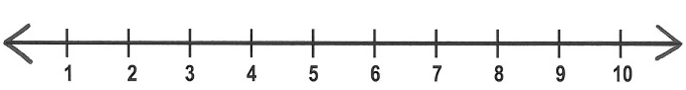

**0**

**Exercise**

1. **3+4=**



**0**



**0**

1. **4+4=**

**Lesson 5**

Subtracting numbers up to 20 both horizontally and vertically.

**Example**

6 - 2= 5 - 5 = 8 - 4 = 10 - 5 = 13 - 0 = 16 - 10 =

7 4 9 8

- 3 - 2 - 5 - 3

**Exercise**

**Subtract / take away**

10 – 0 = 12 - 2 = 20 - 10 = 6 - 6 = 8 - 4 = 15 - 5 =

6 – 3 = 7 – 4 =

3 7 5

- 1 - 2 - 3

**Teaching activity**

Subtracting and counting

**L/aids:** Counters

**Ref: A New Mk Primary maths bk 1 page 68 – 70**

**Primary mathematics for Uganda bk 1 pg 42 – 44**

**Understanding maths bk 1 pg 43 – 45**

**Lesson 6**

Subtraction of numbers 1 -20 involving word problems

**Example**

1. What is twelve take away four?

**12 – 4 = 8**

2. What is nine less two?

1. **– 2 = 7**
2. Mother bought eight apples. She gave three apples to her daughter. How many apples did she remain with?

**8 – 3 = 5**

**Exercise**

**Read and workout**

1. What is nine less four?
2. Father has nine trousers. Three of them are black. How many trousers are not black?
3. Subtract five from eight.
4. What is twenty take away eight?
5. What is seven minus three?

**Teaching activity**

Reading, interpreting and writing

**L/aids:** Counters and textbooks

**Ref: A New Mk Primary maths bk 1 page 71 – 72**

**MK old edition bk 1 page 34.**

**Understanding maths bk 1 pg 45**

**TOPIC: SET CONCEPTS**

**Subtopic: Sorting and naming**

**Lesson 1 and 2**

**Meaning:** A set is a collection of well defined members.

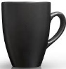**Example**



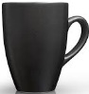



A set of four / 4 balls A set of six / 6 cups.

**Practical work**

**Exercise**

a) Name these sets



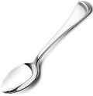









____________________ _______________________

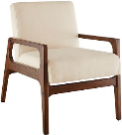







_______________ ________________

**b) Draw these sets**

A set of 7 tables A set of 9 trees

A set of six cats A set of two cars

**Teaching activity**

Sorting, naming and drawing

**L/aids:** books, pencils, cups, spoons, etc

**Ref: A New Mk bk 1 primary maths 2000 page 3.**

**MK Thematic maths practice book 1 page 2**

**Primary school maths bk 2 page 1**

**The N.P.S.C for Uganda page 21, 14**

**Week 8**

**Lesson 3**

**Matching sets (things we use in the classroom)**

**Example**





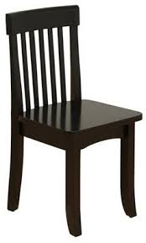

**Exercise**

**Match correctly**







**Teaching activity**

matching and drawing

**Learning Aids: balls, books, pencils, cups, etc.**

***Ref:* Primary school maths bk 2 page 3**

**A New Mk bk 1 primary maths page 4 and 5.**

**MK Thematic maths practice bk 2 page 5.**

**The National Primary sch curriculum for Uganda bk 1 pg 21 - 22**

**Lesson:4**

**Comparing sets**

Example

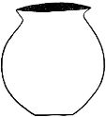 **Set A Set B**









Which set has more members?

**Set A has more members**

Which set has less members?

**Set B has less members**

How many members has set A?

**Set A has four / 4 members.**

How many more members are in set A than in set B?

**4 – 3 = 1**

**1 more member is in set A than in set B**

**Exercise**

Compare these sets

**Set R Set M**

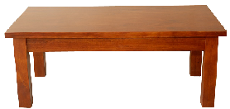



***Questions:***

1. Which set has less / few members?

2. How many members has set R?

3. Which set has more members?

4. How many members are in set R and M altogether?

5. How many more members are in set R than in set M?

**Teaching activity**

counting and comparing

**L/aids:** leaves, tables, chairs, cups, plate, etc

***Ref: MK Bk 2 page 6***

**A New MK Primary MTC BK 1 pg 20-21**

***Primary School MTC Bk2 Pg 2,***

***Pri. Sch. MTC Bk 3 Pg 2-3.***

***The National Primary school Curriculum for Uganda bk 1 page 25.***

**Lesson:5**

**Forming new sets from the big one**

**Example**

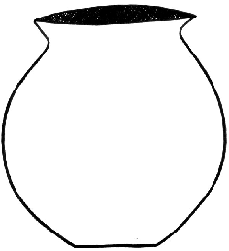



 A set of 3 pots.





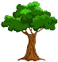 .



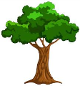 A set of 4 trees.





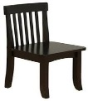



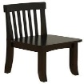 A set of 2 chairs.







A set of 5 books.



**Teaching activity**

Forming and counting and naming

**Learning Aids : books, cups, pencils, balls, etc.**

***Ref: MK Thematic maths practice bk 2 pages 3***

***Primary school maths bk 2 page 1***

***Oxford Primary maths bk 1 page 2 – 3***

***The National Pri school curriculum for Uganda page 21 – 22 book 1***

**Lesson 5**

**An empty set / Null set**

**- Meaning:** An empty set is a set without members.

**Example:**  A set of zebras studying in Greenhill Academy.

A set of boys with 4 heads each.

**The concept of an empty set**

An empty set is a set without members/elements.

The symbol of an empty set if  or

**Exercise**

Draw these empty sets.

A set of trees singing

A set of cups dancing

A set of boxes sleeping

A set of plates cooking

**Write true or false**

A set of spoons jumping. ______________________

A set of girls playing netball. _______________________

A set of chairs smiling. ______________________

A set of girls reading story books. ____________________

**Teaching activity**

Telling examples of empty sets

Reading

***Learning aids:* books, tables, chairs, pencils, etc**

***Ref: A New Mk Pri. MTC 2000 Pupils Bk 3 Pg 11-12.***

**Lesson 6**

**Joining sets**

**Examples**



 + =

**2**  + **3**  = **5**







 + =

**3 + 3 = 6**

**Exercise**

Join these sets

1. 1 + =

5 + 5 = ---------------

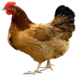

 2. =

 +

3 + 4 = -----------------

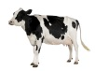

3. + =

4 + 5 = ------------------

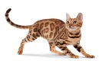

 4. + =



5 + 0 = ----------------





5. + =

2 + 2 = --------------------

**Teaching Activity**

Joining sets and counting

**Learning Aids : books, cups, plates, spoons, balls, etc.**

***Ref: Understanding Mtc Bk 1 Pg 34,***

***A New Mk Pri. MTC2000 Pupils Bk 1 Pg 22-24***

**Lesson 1 and 2**

**Graphs (data interpretation)**

**Pictograph**

4 children picked flowers

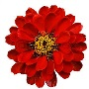

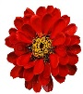









**Sam Dan Tom Ben**

**Questions**

1. Who picked 5 flowers?

2. How many flowers did Sam pick?

3. How many flowers did Tom and Ben pick altogether?

4. Who picked the highest / most number of flowers?

**Teaching activity**

- Studying the graph

- Interpreting the graph

- Answering questions

**L/aids: A chart and text books**

**Ref: MK Standard bk 1 page 13**

**A New MK Primary Mathematics book 1 page 85 – 86**

**Week 10**

**Lesson 3**

**Topic: Measures**

**Time:**

Tell different time of the day.

**Example**

Morning, afternoon, evening and night

Telling time using natural indicators

**Example**

**Sun, shadows, cocks and trees ( oral and practical lesson)**

**Teaching activities: telling time**

**Teaching aids : The environment**

**Days of the week**

**Example**

There are seven / 7 days in a week.

These are:

**Monday, Tuesday, Wednesday, Thursday, Friday, Saturday, Sunday**

The first day of the week is **Sunday**

The last day of the week is **Saturday**.

Which day of the week comes before Tuesday?

**Monday comes before Tuesday.**

**Exercise**

a) Fill in the missing letters

Su___day M___nday Wed___esday

Fr___day S___turday

1. Write correctly

- daysTue - Firdya

- Maydno - Wedaynesd

**Read and answer the questions**

1. What day comes after Wednesday?

2. Which day comes before Thursday?

3. On which day do Christians go for general prayers?

4. On which day do Moslems go for general prayers?

**Teaching activities**

Reading, spelling and writing

**L/aids:** Textbooks

**Ref: A New MK Primary Mathematics 2000 book 1 page 106 – 107**

**MK Standard bk 2 page 133 – 134**

**Understanding Maths bk 4 pg 80**

**Lesson 4 and 5**

**Months of the year**

**Example**

1. January

2. February

3. March

4. April

5. May

6. June

7. July

8. August

9. September

10. October

11. November

12. December

1. How many months are in a year?

**There are 12 months in a year.**

1. Which month comes after March?

**April comes after March**

1. Which is the first month of the year?

**The first month of the year is January.**

**Exercise**

**Fill in the missing letters**

F__bruary

D___cember

M__y

J__n__

A__gust

N___vember

**Write correctly**

Jluy - prAil - Mya -

Fruarbey - Setpemerb -

**Answer the questions**

1. Which is the third month of the year?

2. What month comes before June?

3. Which month is between July and September?

4. In which month do Christians celebrate Easter?

**Teaching activities**

Reading and spelling

**L/aids:** Textbooks

**Ref: A New MK Primary Maths 2000 bk 3 page 138 – 139.**

END